**PeaceWomen Across the Globe (East Asia Regional Office) Report**

Prepared by Jin Peiyun and Lau Kin Chi

1 September 2017

About one hundred women from mainland China, Hong Kong and Taiwan met in Kunming in December 2005 to celebrate the 1000PeaceWomen project and to connect with each other. Since then, the project of PeaceWomen Across the Globe with its activities in China has entered its 12th anniversary.

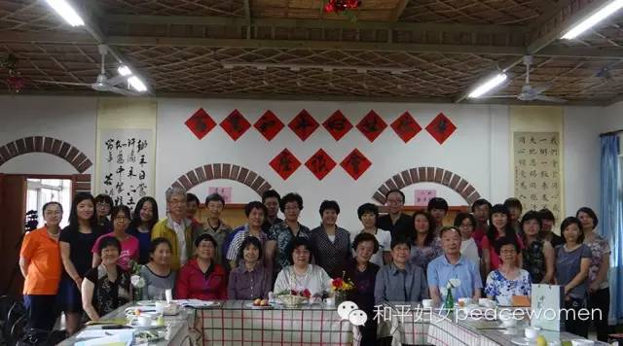

“Seminar on Million PeaceWomen Project”, at Little Donkey Farm, Beijing, June 2015.

In 2015, to commemorate the 10th anniversary of PWAG, the China office convened Workshops and Seminars in Beijing, Ningxia, and Inner Mongolia, and paid visits to over 10 PeaceWomen in Northwest region of China. We reviewed the project’s achievements, and discussed ways to further the project. The new project of writing stories of Million PeaceWomen was welcomed by the Chinese women’s groups.

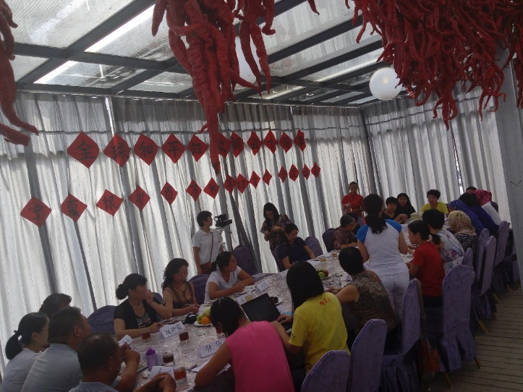

Seminar on PWAG, at Yinchuan, Ningxia, August 2015

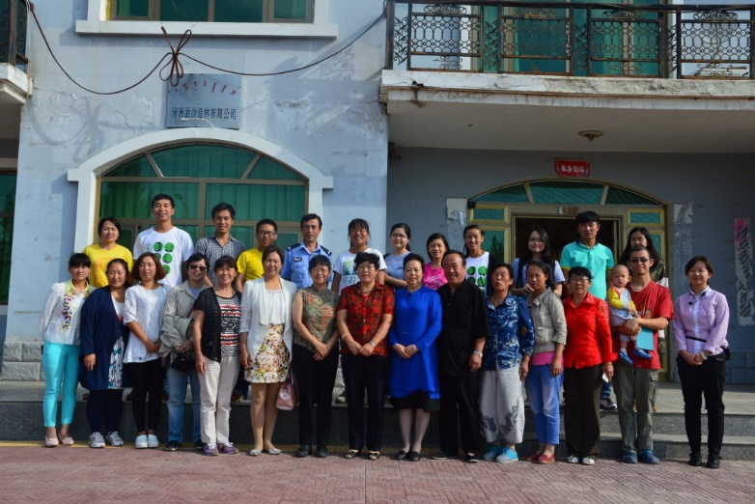

Seminar on PWAG, at Urdos, Inner Mongolia, August 2015

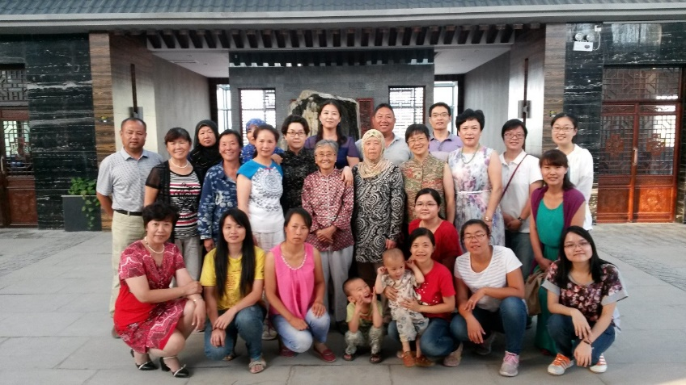

Seminar at Wuzhong Mosque for Girl Students, Ningxia, August 2015.

Apart from visits and seminars, the China Office produced a publication *Pathing Peace, Celebrating Life – commemorating the 10th Anniversary of the PeaceWomen Across the Globe*” which came out in early 2017. It reviews the work of the PWAG China Office in the last decade, and promotes the new WikiPeaceWomen project.

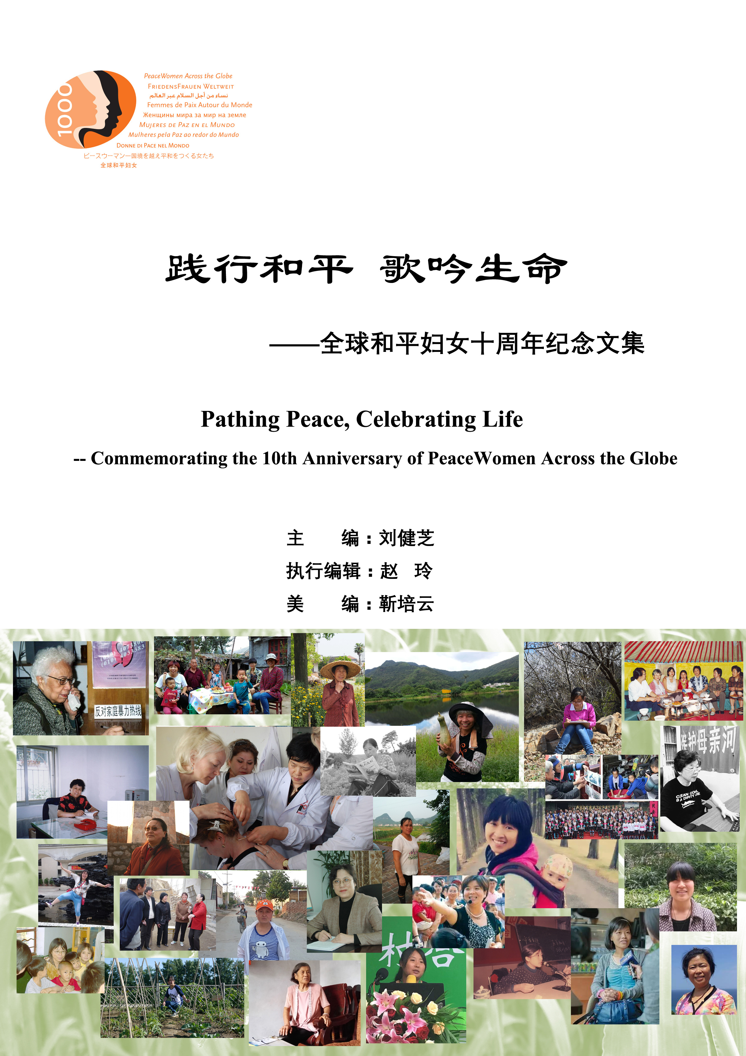

PWAG China Office, working jointly with Renmin University of China, Southwest University, Fujian Agricultural and Forestry University, and Love Our Home Village Association, launched the project “Youths Loving Our Home Village”, and organized activities in university campuses and in social arenas to encourage the collection of peacewomen stories.

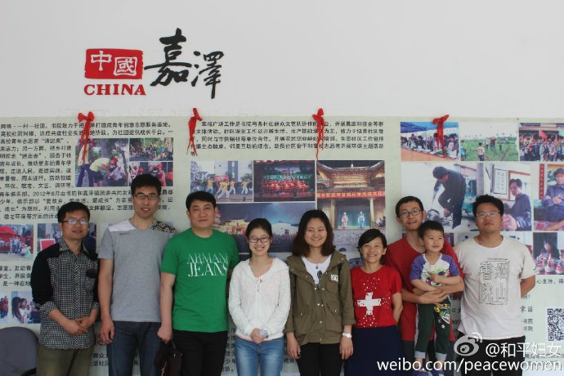

Promoting the Million PeaceWomen Project at Suzhou, Jiangsu Province. May 2016

In Hong Kong, at the East Asia regional office, collaborating with the Global University for Sustainability, a WikiPeaceWomen project team has been working on interviews on life and thought of women activists, organizing seminars, updating Thousand PeaceWomen stories, running the WikiPeaceWomen website in different languages, and collecting Million PeaceWomen stories. The team has updated 25 Chinese Thousand PeaceWomen stories, collected 230 Chinese Million PeaceWomen stories, and translated 95 Chinese stories into English.

We have invited well known women intellectuals to give seminars. They include Helena Norberg-Hodge, Dai Jinhua, and Lui Lai Ping.

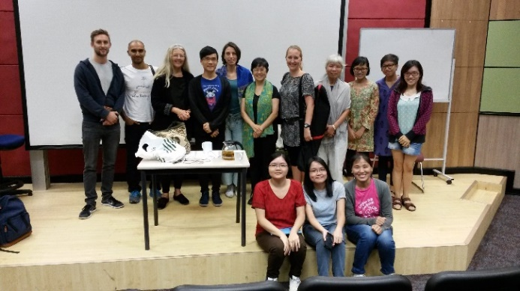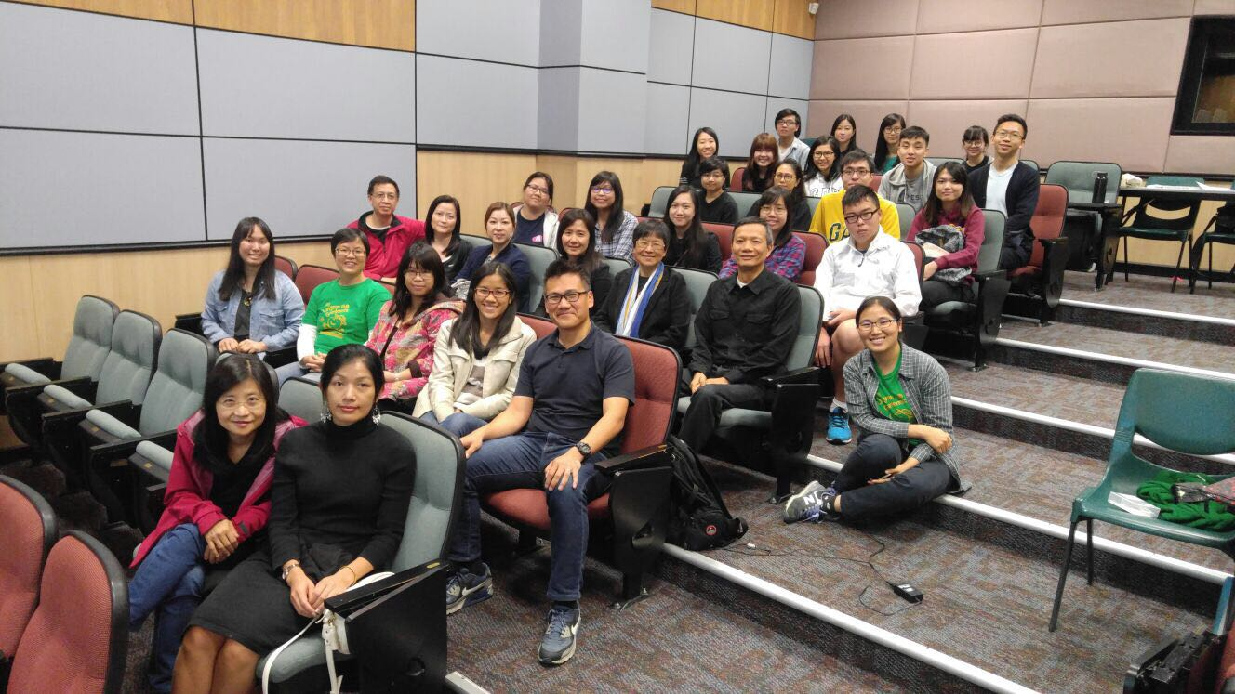Helena Norberg-Hodge (back row, 3rd from left）, September 2015

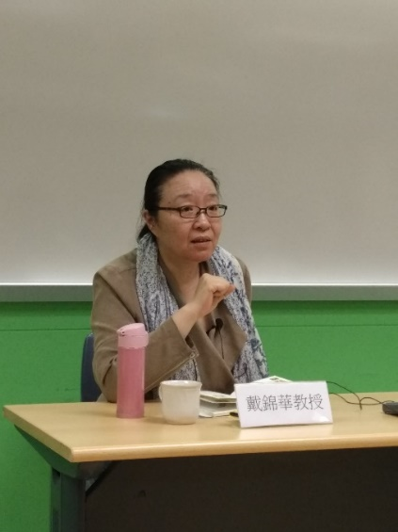

Dai Jinhua, February 2016

Lui Lai Hung (3rd row from the front, 4th person from the left), April 2017

The WikiPeaceWomen project has attracted interest from the mass media. Swiss TV SRF filmed the work of Hong Kong Million PeaceWoman Dr Chan Shun Hing and reported on the WikiPeaceWomen project: ：<https://www.srf.ch/play/tv/mitenand/video/kin-chi-lau-portraitiert-engagierte-frauen?id=ff4b0330-d95e-4799-bc8d-489270fdb6ad>

On 7 July 2017, on the occasion of the Fourth South South Forum on Sustainability, of which WikiPeaceWomen was one of the co-organizers, a Seminar on Women Movements in Asia Building Peace was convened, with about twenty speakers from Korea, Japan, Philippines, and China, including Mina Watanabe, Lee Jung Ok, Son Dug Soo, Dai Jinhua, Chan Shun Hing, Tani Barlow, Amy Yeung, Jessica Tso, and Auyeung Lai Seung.

With China’s economic growth, issues such as labour, environmental pollution, and agrarian questions are becoming more acute. Though our contribution may be modest, we believe we must make our efforts to bring about some change. The idea and practice of peace by millions of women in China and across the globe are examples giving us hope and strength to move on.

Team members: Lau Kin Chi, Auyeung Lai Seung, Zhao Ling, Jin Peiyun.

East Asia Regional Office of PWAG:

LBY 112, Lingnan University, Tuen Mun, Hong Kong, China.

Tel: +852 6167671/ 26167672

WikiPeaceWomen website: http://wikipeacewomen.org/wpworg/

Email: [wiki.peacewomen@gmail.com](mailto:wiki.peacewomen@gmail.com) [wikiwomen@126.com](mailto:wikiwomen@126.com)

Note: For the details of some of the work reported here, please refer to the WikiPeaceWomen Project report.